Open Source Antibiotics - Simple Diarylimidazoles are Potent Against Methicillin Resistant Staphylococcus Aureus.

Dana M. Klug†, Edwin G. Tse†, Daniel G Silva†§, Yafeng Cao‡, Susan A. Charman₹, Jyoti Chauhan∥, Maria Dichiara∥, Chris Drake₶, David Drewry₸, Flavio da Silva Emery§, Lori Ferrins∥, Lee Graves₸, Emily Hopkins₶, Thomas A. C. Kresina∥, Álvaro Lorente-Macías₸₮, Benjamin Perry₺, Richard Phipps₶, Bruno Quiroga∥, Antonio Quotadamo∥≠, Giada Sabatino†, Anthony Sama¶, Andreas Schätzlein†, Quillon J. Simpson∥, Jonathan Steele₶, Bruno Quiroga∥, Antonio Quotadamo∥≠, Julia Shanu-Wilson₶, Peter Sjö₺, Paul Stapleton†, Chris Swain^{ℓ}, Alexandra Vaideanu†, Huanxu Xie‡, William Zuercher₸, Matthew H Todd†*

†School of Pharmacy, University College London, 29-39 Brunswick Square, London WC1N 1AX
§School of Pharmaceutical Sciences of Ribeirão Preto, University of São Paulo, Ribeirão Preto, São Paulo, 14040-903 Brazil
‡ Wuxi Apptec Shanghai Co Ltd, 288 Fute Middle Road Waigaoqiao Free Trade Zone Shanghai, 200131 China
∥ Department of Chemistry and Chemical Biology, Northeastern University, Boston, Massachusetts 02115, United States of America
≠Clinical and Experimental Medicine PhD Program, University of Modena and Reggio Emilia, 41121 Modena, Italy.
₸ Department of Pharmacology, University of North Carolina at Chapel Hill, Chapel Hill, NC 27599, USA
₮The University of Edinburgh, Old College, South Bridge, Edinburgh EH8 9YL
₹Centre for Drug Candidate Optimisation, Monash Institute of Pharmaceutical Sciences, Monash University, Parkville, VIC 3052, Australia
₺Drugs for Neglected Diseases initiative (DNDi)

¶ Address: email: asamawsfl@protonmail.com
₶Hypha Discovery, 154b Brook Dr, Milton, Abingdon OX14 4SD
^{ℓ}Cambridge MedChem Consulting, 8 Mangers Lane, Duxford, Cambridge CB22 4RN, U.K.

*Corresponding author: matthew.todd@ucl.ac.uk

Abstract

Antimicrobial resistance (AMR) is widely acknowledged as one of the most serious public health threats facing the world, yet the private sector finds it challenging to generate much-needed medicines. As an alternative discovery approach, a small array of diarylimidazoles was screened against the ESKAPE pathogens and the results made publicly available through the Open Source Antibiotics (OSA) consortium. Of the 18 compounds tested (at 32 μg/mL), 15 showed >90% growth inhibition activity against MRSA alone. In the subsequent hit-to-lead optimization of this chemotype, 147 new heterocyclic compounds containing the diarylimidazole and other core motifs were synthesized, tested against MRSA and structure-activity relationships identified. While potent, these compounds have moderate to high clearance rates and some associated toxicity. The best overall balance of parameters was found with OSA_975, a compound with good potency and solubility and slow clearance in rat hepatocytes. We have progressed towards the knowledge of the molecular target of these phenotypically active compounds, with proteomic techniques suggesting ACVR1B and TGFRB1 potentially involved in the mechanism. Further development of these compounds towards antimicrobial medicines is available to anyone under the licensing terms of the project.

Graphical Abstract
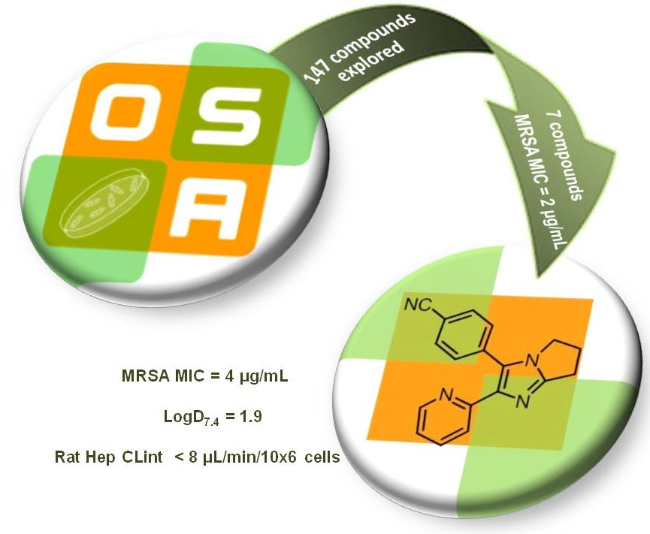
Introduction

Antimicrobial resistance (AMR) is widely acknowledged as one of the most serious public health threats facing the world.¹ The problem may have been worsened by the overuse of antibiotics to treat COVID-19 patients during the pandemic.² Unfortunately, those antibiotics rendered ineffective by resistance are not being replaced at the rate that society needs. Of the 43 antibiotics in clinical development as of December 2020, only six have the requisite activity against World Health Organization (WHO) critical or Centers for Disease Control and Prevention (CDC) urgent pathogens, and only ten represent a novel class or target.³ This shortfall is primarily due to the high cost of antibiotic development and the challenges of creating a market structure in which novel antibiotics are both stewarded responsibly and made profitable.⁴

In this environment, an open source model for drug discovery can offer several advantages.⁵ A project adopting this approach lacks secrecy: it takes place publicly in real time, with all communication in the public domain, and is not based on a patent model.⁶ Such an approach allows for the recruitment of diverse scientific expertise, reduces or eliminates unproductive duplication of effort and enables a competitive yet collaborative assessment of strategies to solve a problem. While such a model has been previously applied to other discovery projects towards, for example, antimalarials⁷ and antifungals,⁸ the project described herein is an example of an open source drug discovery framework applied to the challenge of novel antibiotic discovery.

In an effort to discover new leads against high-priority pathogens, a small array of diarylimidazoles was screened using the Community for Open Antimicrobial Drug Discovery (CO-ADD) screening platform,⁹ which profiled the compounds against the ESKAPE pathogens Escherichia coli, Klebsiella pneumoniae, Acinetobacter baumannii, Pseudomonas aeruginosa, methicillin-resistant Staphylococcus aureus (MRSA) and the fungi Candida neoformans and C. albicans. Of the 18 compounds tested (at 32 μg/mL), 15 showed >90% growth inhibition activity against MRSA but not the other pathogens (See Figures S1 and S2 in Supplementary Information). MRSA is a gram-positive pathogenic bacterium that was designated a high-priority pathogen by the WHO.^{1d} AMR was one of the greatest public health concerns prior to the COVID-19 pandemic; only MRSA infections increased by 13% from 2019 to 2020.¹⁰ Given the potential public health benefits, we decided to pursue hit-to-lead optimization of this series which is exemplified by OSA_822 (MRSA active) and OSA_812 (MRSA inactive) shown in Figure 1.

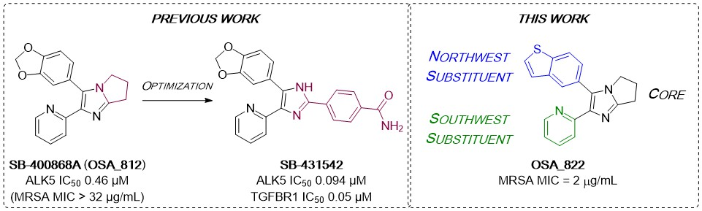
Figure 1. Literature optimization of diarylimidazole SB-400868A to generate ALK5 inhibitors and structure of a representative compound investigated in this work (OSA_822) towards compounds potent vs. MRSA.

The chemotype was of previous interest as a result of a screen of a GlaxoSmithKline internal library collection for inhibitors of the transforming growth factor β1 (TGF-β1) type I receptor (ALK5), where compound OSA_812 displayed an IC₅₀ of 0.46 µM against ALK5 and no inhibition of p38 kinase. Optimization led to the selective inhibitor SB-431542 (IC₅₀ 94 nM against ALK5 and still no inhibition of p38 kinase, LD₅₀ > 30 µM), which inhibits TGF-β1-induced fibronectin mRNA formation (IC₅₀ 0.05 µM) while displaying no measurable cytotoxicity in a 48 hour XTT assay.¹¹

The promising activity against MRSA, and the low cytotoxicity observed in the ALK5 research, stimulated us to pursue a new hit-to-lead campaign. Three regions of the main scaffold were modified; the bicyclic imidazole core (black), the “northwest” aryl substituent (blue), and the “southwest” aryl substituent (green). Diversification of these motifs, as well as their linkages, formed the basis of our synthetic studies of this chemotype. The aim was to generate potent compounds with promising physicochemical and metabolic clearance properties while maintaining an acceptable toxicity vs. mammalian cells.

Results and Discussion

Synthesis

The majority of compounds synthesized for this campaign followed a general three-step route (Scheme 1, A). The starting α-bromoketones 1 were cyclized with the desired 2-amino heterocycles 2 to afford fused bicycles 3. Bromination of the 5-position of the imidazole ring was accomplished using NBS to give 4. Final compounds 5 were synthesized using standard Suzuki coupling conditions under either conventional or microwave heating.

Several analogues were made with a methylene linker between the core and the aryl amine substituent (9). These were prepared via an analogous method, starting with a condensation-cyclization of the appropriate α-bromoketone 1 and aminopyridine 6 to give the imidazopyridine core 7. A Mannich reaction allowed the aminoalkylations necessary for the imidazopyridine derivatives 9;¹² some anilines that were used in this reaction (8) were alkylated prior to the Mannich step (see Supplementary Information).

Nitrogen-linked analogues were accessed via a one-pot Yb(OTf)₃ catalyzed Groebke-Blackburn-Bienaymé reaction with aldehyde 10, isonitrile 11 and aminopyridine 12 to afford compounds 13.¹³ This was followed, if desired, by nucleophilic substitution with an alkyl halide 14 using Cs₂CO₃ to yield N-alkylated compounds 15 (B, Scheme 1).

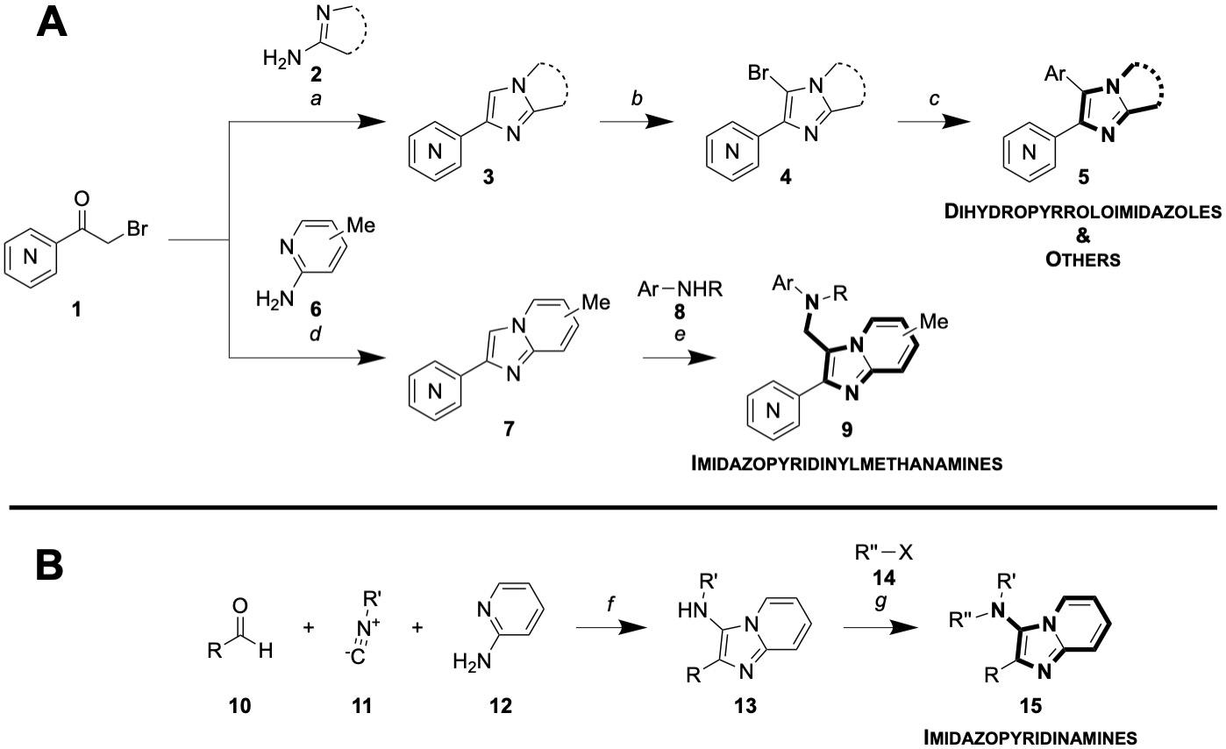

Scheme 1. A) Synthetic route to general (aryl-aryl linkage) analogues. a) 2, DMF, 100 °C, 18 h; b) NBS, DCM, rt, 1 h; c) ArB(OH)₂ or ArB(pin), Na₂CO₃, Pd(PPh₃)₄ or PdCl₂(dppf)CH₂Cl₂, 3:1 PhMe:EtOH, 120 °C, 18 h (conventional heating) or 30 mins (μw reactor); d) 6, NaHCO₃, MeOH, reflux, 12 h; e) 8, formalin (37% aq.), acetic acid, DCM, 18 h. B) Synthetic route to N-linked analogues. f) Yb(OTf)₃, 120 °C, 30 mins (μW reactor); g) 14, Cs₂CO₃, DMF, rt, 18 h. A phenyl ring containing a central N denotes a general (aza)aromatic. Yields are described in Supplementary information.

Structure-activity relationships
In total 147 compounds have been evaluated in this study. The most significant are reported below and these contribute to an understanding of the SAR trends, but all molecules are described in the Supplementary Information and may additionally be found in the online project infrastructure. Twenty-four compounds were donated by the Drugs for Neglected Diseases initiative (DNDi) for which the experimental data have been published.¹⁴ An additional 36 compounds were contributed from Northeastern University, the experimental details for which may be found in a separate publication under review; the compound identities are delineated in the Supplementary Information Tables S1 and S2.
We began our SAR investigations by preparing a wide variety of analogues with variation in the northwest aryl substituent; the aim was to capitalize on the potency of the benzothiophene of 822 while reducing the potential metabolic liabilities of that motif.¹⁵ As shown in Figure 1, several fused bicycles were tolerated; of note is the “reverse” (6-substituted) thiophene 830 that was found to be almost equipotent to the original compound 822 (unlike the less potent 3-substituted analogue 832) and the benzofuran pair 821 and 829 that were similarly potent yet which lack the metabolic liability of the thiophene. Compounds with bicyclic motifs containing unsaturated rings were found to be ineffective (e.g., 827/828), as were aromatic nitrogen-containing fused bicycles (e.g., benzothiazoles 835 and 836, quinoline 833).

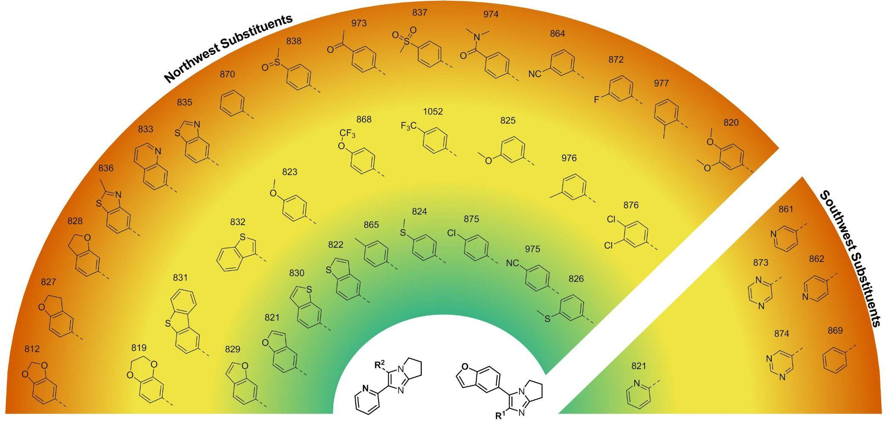
Figure 1. Heat map of in vitro potency against MRSA of analogues with variations in the northwest and southwest substituents. Color gradient: green < 4 μg/mL; yellow < 16 μg/mL; red = 32 μg/mL.

We additionally explored a variety of simpler, substituted phenyl rings at the northwest position. Replacement of the benzofuran moiety in 821 with para-tolyl (865, green region) maintained potency; other para-substituted phenyl rings (e.g., in 824, 875, and 975) resulted in significantly improved activity against MRSA when compared to the analogue with an unsubstituted phenyl ring (870). Small alterations to the para-substituent significantly influenced potency (e.g., 824 vs. 838), though a group in this position generally performed better than the same group in the meta position (e.g., 865 vs. 976, 975 vs. 864). A focussed library based on the promising compound 975 was synthesized and evaluated (Table S2, Supplementary Information) but none of the compounds retained the potency of the parent. More oxidized substituents, such as acyl (973), methyl sulfone (837), or dimethylamide (974), were not tolerated (Figure 1, red region).
We rapidly established the essentiality of the southwest 2-pyridyl substituent: unlike compound 821, pyridine isomers 861 and 862 were inactive, as were the unsubstituted phenyl compound (869) and the pyrazines 874 and 873.
Our SAR investigations then focused on evaluation of fused aromatic cores (Figure 2). Compounds 859 and 986, containing a benzo-fused core and a northwest aromatic moiety, were inactive, but the potency could be mitigated by fine-tuning of the substituents (e.g., p-Me (1018) or p-(NEt₂) (1011)) and, interestingly, the introduction of a nitrogen atom spacer in compound 987 that was seen as promising because of the introduction of an amine providing an additional point of diversity and potentially better solubility. This compound was explored through variation of other coordinating rings in the southwest (1022, 847, 1008 and 1009) with no improvement in potency.
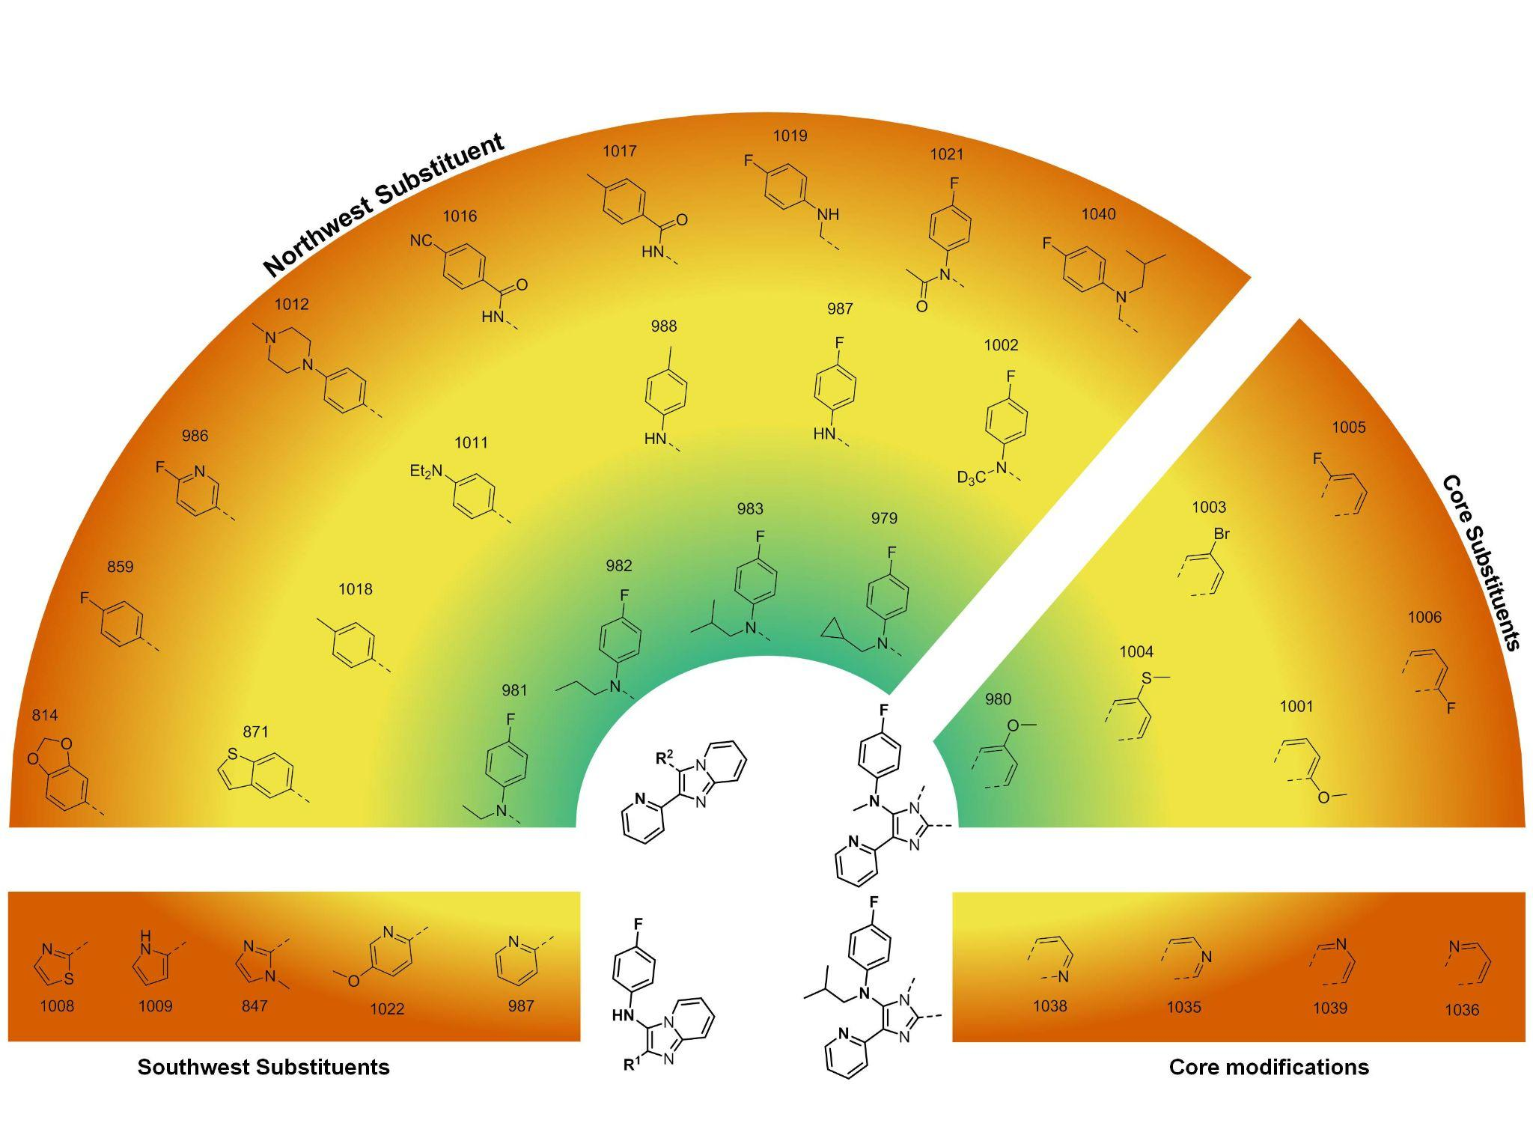
Figure 2. Heat map of in vitro potency against MRSA of analogues containing fused bicyclic cores. Color gradient: green < 4 μg/mL; yellow < 16 μg/mL; red = 32 μg/mL.

Acylation (1021) or homologation (1019) of the amine provided no benefit, but a significant improvement in potency was seen with alkylation of the nitrogen atom (979, 981-983). While maintaining this motif, it was found that some substitutions were acceptable on the fused aromatic core (e.g., 6-methoxy in 980) though with a high degree of sensitivity to such substitutions (e.g., lower potencies seen with structurally close isomers (1001) or analogues with other minor changes (1003-1006)). While it was hoped the use of an aza-aromatic ring in the fused core might help with solubility, a nitrogen atom in any of the four available positions on that ring (i.e., 1035, 1036, 1038, 1039) was deleterious to potency. An obvious final structure to explore, 1,2-disubstituted benzimidazole, was briefly explored but provided only inactive compounds (Table S2, Supplementary Information).
Due to the lack of antibiotics for the treatment of multidrug-resistant enterococcal infections, we also tested selected compounds against vancomycin-resistant enterococcus (VRE; see Tables S1 and S2 in Supplementary Information). Significantly, of these 979 and 982 also showed potent MICs (MIC = 4 µg/mL) against VRE.
From the above campaign that aimed to optimize potency of this series against MRSA, 147 heterocyclic compounds were synthesized and tested, of which 88 were inactive (MIC > 32 µg/mL) 11 were moderately active (MIC = 16 µg/mL) and 43 displayed promising potency (MIC ≤ 8 µg/mL).

ADME and Pharmacokinetics

To guide our initial SAR exploration work, we obtained liver microsomal clearance data for 5 of the initial 18 compounds assayed by CO-ADD (Tables S3 and S4, Supplementary Information). We acquired clearance and solubility data on further compounds throughout the SAR campaign. Our target was to identify compounds with promising characteristics for lead development: MIC < 4 µg/mL, aqueous solubility ≥ 10 μM, Chrom Log D_{7.4} values below 2, mouse liver CL_{int} < 9.0 µL/min/mg protein, rat hepatocyte CL_{int} < 5 µL/min/10 x 6 cells and PPB ≤ 95%. The data for selected compounds (full data are available at the Tables S3 and S4 in Supplementary Information) show that these compounds have moderate to high clearance rates (Figure 3). In general, potency was negatively correlated with solubility, in that the most potent compounds were poorly soluble.

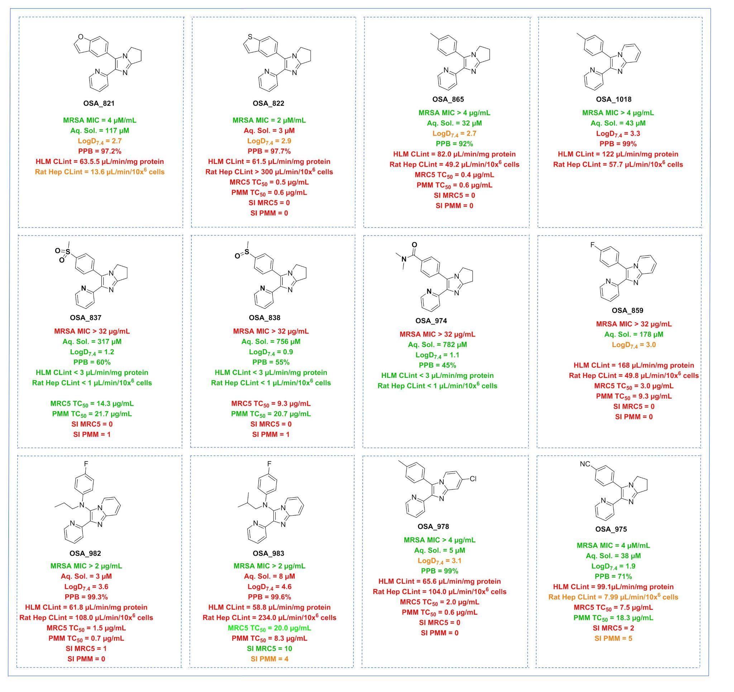
Figure 3: Human and rat liver microsome clearance data and mammalian cells line results. MRSA MIC data units are μg/mL. SI = ratio of cytotoxic TC₅₀ and MRSA MIC.

Of the initially-studied compounds, the potent benzofuran 821 performed better than the potent benzothiophene 822 (particularly in rat liver microsomes) though it is also known that benzofuran-containing compounds can undergo metabolic activation at the 2-position^{15b} which had made replacement of this functionality a priority for series development. To probe experimentally the cause of metabolic liability in the promising benzofuran, this compound was screened with a PolyCYPs enzyme panel kit (provided by Hypha Discovery) that identified one main monohydroxylated metabolite. These matched the monohydroxylated metabolite observed in human liver S9 incubations, with an additional glucuronide produced in human liver S9 tissue. (see Supplementary Information). Following a scale-up reaction with one of the PolyCYP enzymes, it was possible to identify the main hydroxylated metabolite (997, Figure 4) resulting from oxidation on the unsaturated core at the 7-position. This metabolite was found to be inactive when evaluated vs. MRSA. The metabolic liability identified for the benzofuran did not appear to be responsible for the clearance numbers obtained, since compounds with such a motif displayed similar rates of clearance to analogous compounds with a fully aromatic core (e.g., 865 vs 1018).

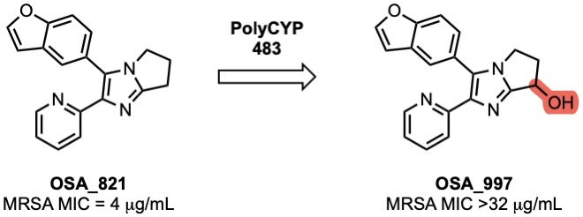
Figure 4. Structure and MRSA activity of a metabolite of OSA_821.

Several compounds displayed low rates of microsomal clearance (e.g., HLM CLint < 3 ug/min/mg for 837, 838 and 974) in tandem with good solubility, but these compounds were not potent. The fully aromatic (imidazopyridine 1018) vs partially aromatic (diarylimidazole 865) cores performed approximately equivalently. The introduction of the nitrogen linker between rings did not have the expected impact on compound solubility (e.g., 859 vs 982, 982 and 983).
To judge selectivity of selected compounds for MRSA vs. other cells, toxicity was evaluated to MRC-5_{SV2} (human lung fibroblast cell line) and PMM (primary mouse macrophages) and the selectivity index (SI = ratio of cytotoxic TC₅₀ and MRSA MIC) calculated (additional data can be found at Table S5 in Supplementary Information). Most of the inactive compounds exhibited low toxicity to either cell line. However, some of the most potent compounds displayed low SI due to toxicity in mammalian cells line (e.g. 822, 865, 978 and 982). The imidazopyridine 983 showed a good selectivity index (SI = 10) for the MRC5 cell line, but this was accompanied by poor ADME properties. The best overall balance of parameters was found with 975, a potent compound with reasonable solubility and slow clearance in rat hepatocytes, with low toxicity against MRC5 cell line and no toxicity against PMM.

Alex V: your toxicity data and conclusions go here. Figure 5.

Mechanism of Action
To understand the mammalian toxicity of diarylimidazoles derivatives, and to aid in future compound design, we experimentally investigated the potential series mechanism of action (MoA). A representative active (822) and inactive (820) compound were profiled using the MIB-MS (multiplexed inhibitor beads with mass spectroscopic detection) proteomic technique.[REF from Lee Graves describing/using the technique] The results (Figure 6) suggested that TGF-β1 and ACVR1B (Activin A Receptor Type 1B) could potentially be the mammalian target for this series of compounds and explain the cytotoxicity observed.
Contrast with MRSA lysate experiments. Lee - your data go here.

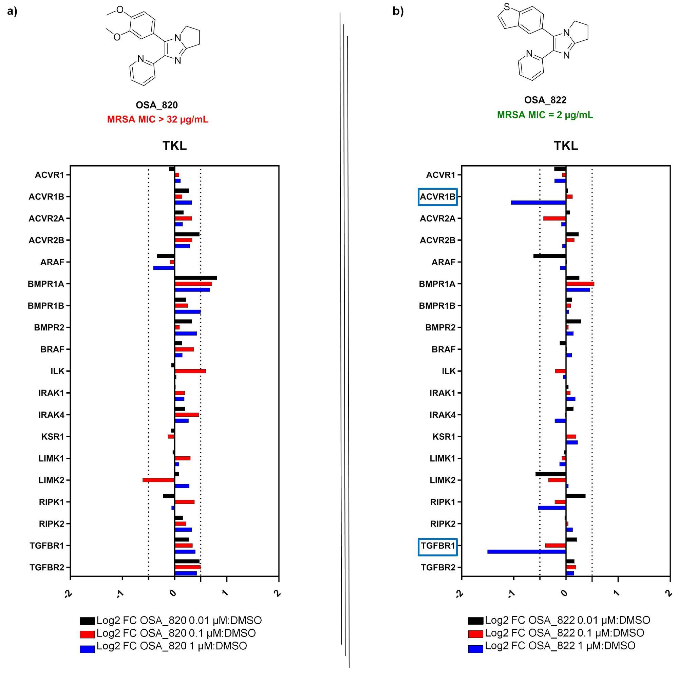
Figure 6. Lee – Please Describe and then walk us through what we’re looking at. Will need to combine with MRSA data, meaning we may need to reduce how much we show, with full data in SI.

Support for TGF-β1 being the target comes from a report of compounds similar in structure to 822 (see SI for structures and docking) bound to this protein (PDB: 3TZM and 1RW8).¹⁶

Conclusions and Next Steps

Building on publicly available data derived from a COADD screen, we have investigated the promising activity against MRSA of a set of diarylimidazoles. Through synthetic variation of the core structure we have identified simple molecules with good potency, solubility and low metabolic clearance; the identification of a metabolite was made possible by a private sector contribution to this open research project. Potency tended to correlate with toxicity to mammalian cells, and through experimental investigation of the series’ mechanism of action we have identified XXX as potential mammalian and bacterial targets. Unanswered questions that could be pursued next for this series include: 1) , 2) and 3). Continuation of this research is made straightforward by the availability of all data, and a platform for collaboration, on the Open Source Antibiotics infrastructure.

Acknowledgements
NEU acknowledge funding from the National Institute of Allergy and Infectious Diseases (R33AI141227). We are grateful to Fundacão de Amparo à Pesquisa do Estado de São Paulo (FAPESP) for funding (grant numbers: #2017/22001-0 and 2021/11899-0 (DGS)). We thank AstraZeneca for the provision of the in vitro ADME and physicochemical properties data included in the manuscript. We acknowledge funding from Pharmalliance (a coalition of the School of Pharmacy (University College London), the Eshelman School of Pharmacy (University of North Carolina at Chapel Hill) and the Faculty of Pharmacy and Pharmaceutical Sciences (Monash University), grant PA2019TierB_ID31. We thank CO-ADD for performing the initial screen that identified this series and Dr Fahima Idiris (UCL, now Pharmaron), Dr James Callahan (GSK) and Professor Robert Hanson (NEU) for helpful early discussions.

Supporting Information List

Original COADD data
https://github.com/opensourceantibiotics/Series-2-Diarylimidazoles/blob/master/Paper%20files/SI%20files/CO-ADD%20DAI%20array%20MIC%20data%20P0700%20.xlsx

Full List of Compounds Made
Downloaded Excel sheet from the Master List that includes ADME and tox

Hypha MS Traces
https://github.com/opensourceantibiotics/Series-2-Diarylimidazoles/blob/master/Paper%20files/SI%20files/Hypha_OSA_000821_HPLC.docx

NMR Traces of Hypha Metabolite (OSA997)
https://github.com/opensourceantibiotics/Series-2-Diarylimidazoles/blob/master/Paper%20files/SI%20files/Hypha%20Metabolite%201D_2D%20NMRs.pdf

https://github.com/opensourceantibiotics/Series-2-Diarylimidazoles/blob/master/Paper%20files/SI%20files/Hypha%20metabolite.mnova

References

In this paper, the numbering of the compounds retains the numbering used in the online Open Source Antibiotics project, maintaining the connection between data in this paper and the live research. Molecules in Open Source Antibiotics are numbered according to a convention described online (https://github.com/opensourceantibiotics/OSA_Tech_Ops/wiki/Molecule-Numbering-Convention) and in the Supporting Information.

